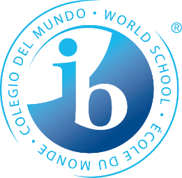

Student Residence – Application Form 2022 – 2023
STUDENT
Surname: |  |  |  | Cpr.no. (date of birth)
First name(s): |  |  |  | Nationality: | Sex:  - Female | - Male
Street:

Postal code, city, country:

Phone: |  |  |  | E-mail:
Please indicate your programme of study: |  |  |  | Please indicate your sport: (If IB-Sport student)
- IB-Sport | - IB | - STX | - HF

PARENTS/GUARDIANS
Surname: | Cpr.no. (date of birth)
First name(s): | Nationality: | Sex:  - Female | - Male
Street:

Postal code, city, country:

Phone: | E-mail:

TYPES OF ROOMS
Types of rooms | Registrations fee* | Rent per month  (All inclusive) | Please indicate preference of room:
Sports student double room | 5.500,- DKK | 4.500,- DKK
Sports student single room | 5.500,- DKK | 5.700,- DKK
Non-sports student double room | 5.500,- DKK | 4.500,- DKK
Non-sports student single room | 5.500,- DKK | 5.700,- DKK

BANK DETAILS
Bank:  Nordea Bank, Ikast | Account number:  2760-4377 821 624 | IBAN:  DK182000 4377 821 624 | SWIFT:  NDEADKKK
*50% of the Registrations fee must be payed along with this application. Last 50% must be payed when the application is approved. If the student does not start at school in august there will be no refund of the registrations fee.

Date: ______________ Applicant´s / Guardian´s signature: _________________________________________

